

CORRELATION, REGRESSION AND CURVE
FITTING

Yash Fichadiya/Hardik Gupta
Department Of Applied Science & Humanities, PIET
Parul University

Study Guide

INDEX
Sr. No. | Topics | Subtopics | Page No.
1 | Introduction to Correlation | Meaning, Purpose, Examples | 2
2 | Types of Correlation | Positive, Negative, Zero, Linear, Non-linear, Simple, Multiple | 3-4
3 | Scatter Diagram | Concept, Interpretation, Types of patterns | 5-7
4 | Karl Pearson’s Correlation Coefficient | Definition, Assumptions, Step-by-step procedure | 8
5 | Pearson’s Correlation Formulae | Actual formula, Computational formula, Derivations | 9
6 | Examples on Karl Pearson’s Method | Tabular data solving, Negative correlation, Positive correlation | 9-12
7 | Spearman’s Rank Correlation | Definition, Formula, Uses | 12
8 | Spearman’s Rank Method with Tied Ranks | Handling ties, Adjusted formula | 12-13
9 | Examples on Spearman Rank Correlation | Numerical examples, Step-by-step calculation | 13-15
10 | Regression Analysis – Introduction | Meaning, Need, Prediction concept | 16
11 | Regression Lines | Line of Y on X, Line of X on Y, Interpretation | 16-17
12 | Regression Coefficients | byx, bxy, Formula, Calculation method | 16-17
13 | Properties of Regression Coefficients | r² = byx × bxy, scale/origin rules | 16-17
14 | Full Regression Example | Solving step-by-step, Finding two regression lines | 17-19
15 | Curve Fitting – Introduction | Meaning, Need, Best fit concept | 19
16 | Least Squares Method | Error minimization, Derivation idea | 19-20
17 | Straight Line Fit (y = a + bx) | Normal equations, Procedure | 20-22
18 | Quadratic Curve Fit (y = a + bx + cx²) | Normal equations, Solving method | 23-25
19 | Exponential Curve Fit | y = Ce^(ax), Log transformation | 25
20 | Solved Examples on Curve Fitting | Linear, Quadratic, Exponential models | 25-27

Reference Book Books 27

Introduction to Correlation

Meaning of Correlation
Correlation is a statistical technique that measures the degree of relationship between two numerical variables.
It tells us how one variable changes when the other changes.
Examples:
- Height & Weight
- Temperature & Ice-cream Sales
- Demand & Price

Purpose of Studying Correlation
Correlation helps to:
- Understand the strength of the relationship
- Identify the direction of change (increase or decrease)
- Support decision-making with data
- Detect trends and patterns in business, economics, science, engineering, etc.

Importance
- Helps in prediction
- Measures reliability of estimates
- Useful in modelling and forecasting

Basic Notations
If two variables X and Y are observed together:
- X → Independent variable
- Y → Dependent variable
- (xi, yi) → Paired observations

Key Idea
- Positive correlation: both variables move in the same direction
- Negative correlation: variables move in opposite directions
- Zero correlation: no relationship

Types of Correlation
Correlation can be classified based on direction, form, and number of variables.
Your lecture notes PDF contains all types, so here is the refined version:

Based on Direction of Relationship

A. Positive Correlation
When both variables move in the same direction.
- Increase in X → Increase in Y
- Decrease in X → Decrease in Y
Examples:
- Height & Weight
- Study Time & Marks

B. Negative Correlation
When variables move in opposite directions.
- Increase in X → Decrease in Y
- Decrease in X → Increase in Y
Examples:
- Price & Demand
- Speed & Travel Time

C. Zero Correlation
No relationship between the variables.
- Movement of X does not affect Y.
Example:
- Shoe size & Intelligence

Based on Linearity of Relationship

A. Linear Correlation
Relationship between variables can be represented by a straight line.
- Used when change in Y is proportional to X.

B. Non-Linear (Curvilinear) Correlation
Relationship cannot be represented by a straight line; it is curved.
- Used when rate of change varies.

Based on Number of Variables

A. Simple Correlation
Relationship between two variables only (X and Y).

B. Multiple Correlation
Relationship of one variable with two or more variables.
Example:
- Y related to (X₁, X₂)

C. Partial Correlation
Studies correlation between two variables while keeping other variables constant.

Summary
- Correlation indicates direction and degree of relationship
- It may be positive, negative, or zero
- It may be linear or non-linear
- It may involve two or multiple variables

Scatter Diagram

Meaning of Scatter Diagram
A scatter diagram is a graphical method used to study the relationship between two variables.
- One variable is plotted on the X-axis and the other on the Y-axis.
- Each pair of values (xi,yi)(x_i, y_i)(xi​,yi​) is plotted as a point on the graph.
The pattern of these points shows the direction and strength of correlation.

Procedure
- Take variable X on the horizontal axis.
- Take variable Y on the vertical axis.
- Plot the ordered pairs (xi,yi)(x_i, y_i)(xi​,yi​).
- Observe the trend or pattern formed by the plotted points.

Interpretation of Scatter Diagram
From the distribution of points, we can identify:
- Upward rising pattern → Positive correlation
- Downward falling pattern → Negative correlation
- No specific pattern → Zero correlation
- Points form a straight line → Perfect correlation
  - Same direction → Perfect positive correlation
  - Opposite direction → Perfect negative correlation

Example 1
Given: Taxable income vs. Income tax for 5 persons.
Points plotted:
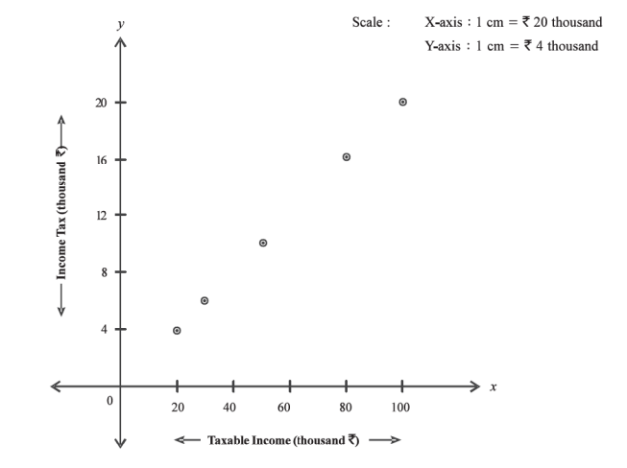

(50,10), (30,6), (80,16), (20,4), (100,20)
Conclusion:
All points lie on a straight line with an increasing trend → Perfect positive correlation.

Example 2
Given: Monthly expenditure vs. monthly savings for 5 families.
Points plotted:
(15,5), (18,2), (8,12), (10,10), (12,8)
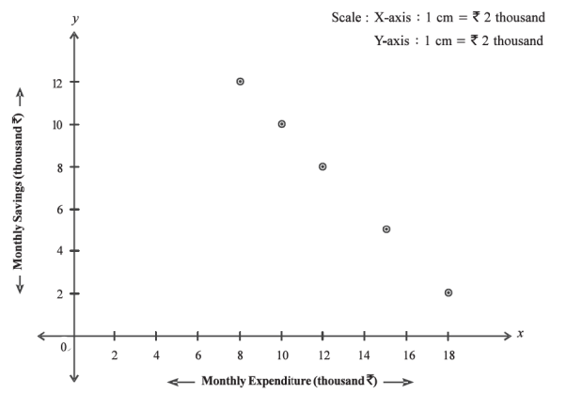

Conclusion:
Points lie on a straight line with a decreasing trend → Perfect negative correlation.

Uses of Scatter Diagram
- Simplest method to detect correlation
- Gives visual idea about strength of relationship
- Helps to identify outliers
- Supports model selection (linear or non-linear)
Karl Pearson’s Correlation Coefficient (r)

Meaning
Karl Pearson’s correlation coefficient r measures the degree and direction of linear relationship between two variables X and Y.
It shows:
- How strongly the variables are related
- Whether the relationship is positive or negative

Formula (Actual Formula)

$r=\frac{∑\left(x-\overline{x}\right)\left(y-\overline{y}\right)}{∑{\left(x-\overline{x}\right)}^{2}∑{\left(y-\overline{y}\right)}^{2}}$​

Computational Formula

$$r =\frac{n∑xy-\left(∑x\right)\left(∑y\right)}{\sqrt{\left(n∑x^{2}-{\left(∑x\right)}^{2}\right) } \sqrt{(n∑y^{2}-{\left(∑y\right)}^{2})}}$$
Where:
- n = number of pairs
- x, y = variables
Interpretation of r
Value of r | Meaning
+1 | Perfect Positive Correlation
–1 | Perfect Negative Correlation
0 | No Linear Correlation
0 to +1 | Positive correlation
–1 to 0 | Negative correlation

Example : 1
Calculate the correlation coefficient between $x$ and $y$ using the following data:
$$x$$ | 10 | 20 | 30 | 40 | 50
$$y$$ | 95 | 90 | 85 | 80 | 75

Solution:

X | Y | XY | X² | Y²
10 | 95 | 950 | 100 | 9025
20 | 90 | 1800 | 400 | 8100
30 | 85 | 2550 | 900 | 7225
40 | 80 | 3200 | 1600 | 6400
50 | 75 | 3750 | 2500 | 5625
Σ | Σ | Σ | Σ | Σ
150 | 425 | 12250 | 5500 | 36375

$$r =\frac{n∑xy-\left(∑x\right)\left(∑y\right)}{\sqrt{\left(n∑x^{2}-{\left(∑x\right)}^{2}\right) } \sqrt{(n∑y^{2}-{\left(∑y\right)}^{2})}}$$

$$r =\frac{(5)(12250)-\left(150\right)(425)}{\sqrt{\left(5\right)\left(5500\right) -{\left(150\right)}^{2} }\sqrt{\left(5\right)\left(36375\right) -{\left(425\right)}^{2} }}$$

$$∴r=0.999$$

Conclusion:
Perfect negative correlation

Example : 2
Calculate the correlation coefficient between $x$ and $y$ using the following data:
$$x$$ | 2 | 4 | 6 | 8 | 10
$$y$$ | 5 | 9 | 12 | 15 | 19

Solution:

$$r =\frac{n∑xy-\left(∑x\right)\left(∑y\right)}{\sqrt{\left(n∑x^{2}-{\left(∑x\right)}^{2}\right) } \sqrt{(n∑y^{2}-{\left(∑y\right)}^{2})}}$$

X | Y | XY | X² | Y²
2 | 5 | 10 | 4 | 25
4 | 9 | 36 | 16 | 81
6 | 12 | 72 | 36 | 144
8 | 15 | 120 | 64 | 225
10 | 19 | 190 | 100 | 361
Σ | Σ | Σ | Σ | Σ
30 | 60 | 428 | 220 | 836

$$r =\frac{(5)(12250)-\left(150\right)(425)}{\sqrt{\left(5\right)\left(5500\right) -{\left(150\right)}^{2} }\sqrt{\left(5\right)\left(36375\right) -{\left(425\right)}^{2} }}$$

$$∴r=0.999$$

Conclusion:
Nearly perfect positive correlation.

Advantages of Pearson’s Method
- Simple and widely used
- Uses all observations
- Gives exact measure of strength
- Suitable for quantitative data

Limitations
- Measures only linear correlation
- Affected by extreme values
- Not suitable for ranked data
- Cannot detect non-linear relationships

Properties of Karl Pearson’s Correlation Coefficient (r)

1. The coefficient of correlation lies between -1 and 1, i.e., −1 ≤𝑟 ≤ 1.
2. Correlation coefficient is independent of change of origin and change of scale.
3. Two independent variables are uncorrelated.

Based on Covariance
The coefficient r is a standardized form of covariance:
$r=\frac{Cov\left(X,Y\right)}{σ_{x } σ_{y}}$ ​
So:
- r > 0 when Cov(X,Y) > 0
- r < 0 when Cov(X,Y) < 0
Example:
Given n = 10, $σ_{x }$= 5.4, $σ_{y}$= 6.2, and sum of the product of deviations from the mean of 𝑥 and 𝑦 is 66. Find the correlation coefficient.
Solution:
n = 10, $σ_{x }$= 5.4, $σ_{y}$= 6.2
$$∑\left(x-\overline{x}\right)\left(y-\overline{y}\right)=66$$
Cov(x,y) = $\frac{∑\left(x-\overline{x}\right)\left(y-\overline{y}\right)}{n}=\frac{66}{10}=6.6$
$$r=\frac{Cov\left(X,Y\right)}{σ_{x } σ_{y}}= \frac{6.6}{5.4*6.2}=0.197$$

Exercise:
1. Find the Pearson’s Correlation Coefficient of the following data:
$$x$$ | 100 | 101 | 102 | 102 | 100 | 99 | 97 | 98 | 96 | 95
$$y$$ | 98 | 99 | 99 | 97 | 95 | 92 | 95 | 94 | 90 | 91

2. Calculate Karl Pearson’s coefficient of correlation for the data given below:
$$x$$ | 10 | 14 | 18 | 22 | 26 | 30 | 10
$$y$$ | 18 | 12 | 24 | 6 | 30 | 36 | 18
3. Find the Pearson’s Correlation Coefficient of the following data:
$$x$$ | 9 | 8 | 7 | 6 | 5 | 4 | 3 | 2 | 1
$$y$$ | 15 | 16 | 14 | 1 | 11 | 12 | 10 | 8 | 9
(Winter 2022-23)
- Find Coefficient of Correlation between the following data:
$$x$$ | 1 | 2 | 3 | 4 | 5 | 6 | 7 | 8 | 9
$$y$$ | 9 | 8 | 10 | 12 | 11 | 13 | 14 | 16 | 15

(Winter 2023-24)

5. Calculate Karl Pearson’s coefficient of correlation for the data given below:
$$x$$ | 17 | 19 | 21 | 26 | 20
$$y$$ | 23 | 27 | 25 | 26 | 27
6. Given n = 10, $σ_{x }$ = 10.8, $σ_{y}$ = 12.4, and sum of the product of deviations
from the mean of $x$ and $y$ is 132. Find the correlation coefficient.

Spearman’s Rank correlation coefficient:
Spearman's rank correlation coefficient, often denoted by the symbol $ρ$ (rho), is a non-parametric measure of statistical dependence between two variables.

Here’s a brief explanation of how Spearman’s rank correlation coefficient is calculated.

Rank the data: For each variable, rank the data from lowest to highest, assigning a rank to each value. If there are ties, assign each tied value the average of the ranks it would have received if there were no tie.
Calculate the differences between ranks: For each pair of data points, find the difference between their ranks.
Spearman’s Rank correlation coefficient:
Calculated by following formula: $r=1-\frac{6∑d^{2}}{n\left(n^{2}-1\right)}$
Where n = number of pair
In case finding out rank correlation coefficient when the observations are paired, the above formula can be written as:
$$r=1-\frac{6\left\{∑d^{2}+\frac{m}{12}\left(m^{2}-1\right)+\frac{m}{12}\left(m^{2}-1\right)+ ………………\right\}}{n\left(n^{2}-1\right)}$$
In $∑d^{2},\frac{m}{12\left(m^{2}-1\right)}$ is added where $m$ is the number of times an item is repeated is.

The value of $ρ$ lies between -1 and 1. A positive value indicates a positive monotonic relationship, while a negative value indicates a negative monotonic relationship. A value of 0 indicates no monotonic relationship.

Example: 1
Two judges have given ranks to 10 students for their honesty. Find the rank correlation coefficient of the following data:

1ST Judge | 3 | 5 | 8 | 4 | 7 | 10 | 2 | 1 | 6 | 9
2nd Judge | 6 | 4 | 9 | 8 | 1 | 2 | 3 | 10 | 5 | 7
Solution

Rank given  by 1st judge | Rank given  by 2nd judge | Difference in  ranks d | $$d^{2}$$
3 | 6 | $$-3$$ | 9
5 | 4 | 1 | 1
8 | 9 | $$-1$$ | 1
4 | 8 | $$-4$$ | 16
7 | 1 | 6 | 36
$$10$$ | 2 | 8 | 64
2 | 3 | $$-1$$ | 1
1 | $$10$$ | $$-9$$ | 81
6 | 5 | 1 | 1
9 | 7 | 2 | 4
 |  |  | $∑d^{2}$=214

$$r=1-\frac{6∑d^{2}}{n\left(n^{2}-1\right)}=1-\frac{6(214)}{10\left(100-1\right)}=1-\frac{1284}{990}=1-1.30=-0.3$$

Example: 2

Ten students got the following percentage of marks in mathematics and physics.
(x)maths | 8 | 36 | 98 | 25 | 75 | 82 | 92 | 62 | 65 | 35
(y)physics | 84 | 51 | 91 | 60 | 68 | 62 | 86 | 58 | 35 | 49
Find the rank correlation coefficient.
Solution

$$n=10$$
$$x$$ | $$y$$ | Rank in maths ($x$) | Rank in physics ($y$) | $$d=x-y$$ | $$d^{2}$$
8 | 84 | 10 | 3 | 7 | 49
36 | 51 | 7 | 8 | –1 | 1
98 | 91 | 1 | 1 | 0 | 0
25 | 60 | 9 | 6 | 3 | 9
75 | 68 | 4 | 4 | 0 | 0
82 | 62 | 3 | 5 | –2 | 4
92 | 86 | 2 | 2 | 0 | 0
62 | 58 | 6 | 7 | –1 | 1
65 | 35 | 5 | 10 | –5 | 25
35 | 49 | 8 | 9 | –1 | 1
 |  |  |  | $$∑d=0$$ | $$∑d^{2}=90$$

$$r=1-\frac{6∑d^{2}}{n\left(n^{2}-1\right)}=1-\frac{6(90)}{10\left(100-1\right)}=0.455$$

Example: 3
Find the Coefficient of rank correlation of the following data: (Summer 2022-23)
$$x$$ | 35 | 40 | 42 | 43 | 40 | 53 | 54 | 49 | 41 | 55
$$y$$ | 102 | 101 | 97 | 98 | 38 | 101 | 97 | 92 | 95 | 95

Solution
$$n=10$$

$$x$$ | $$y$$ | Rank in ($x$) | Rank in (y) | $$d=x-y$$ | $$d^{2}$$
35 | 102 | 10 | 1 | 9 | 81
40 | 101 | 8.5 | 2.5 | 6 | 36
42 | 97 | 6 | 5.5 | 0.5 | 0.25
43 | 98 | 5 | 4 | 1 | 1
40 | 38 | 8.5 | 10 | -1.5 | 2.25
53 | 101 | 3 | 2.5 | 0.5 | 0.25
54 | 97 | 2 | 5.5 | -3.5 | 12.25
49 | 92 | 4 | 9 | -5 | 25
41 | 95 | 7 | 7.5 | -0.5 | 0.25
55 | 95 | 1 | 7.5 | -6.5 | 42.25
 |  |  |  |  | $$∑d^{2}=200.50$$

$$r=1-\frac{6\left\{∑d^{2}+\frac{m}{12}\left(m^{2}-1\right)+\frac{m}{12}\left(m^{2}-1\right)+\frac{m}{12}\left(m^{2}-1\right)+\frac{m}{12}\left(m^{2}-1\right) \right\}}{n\left(n^{2}-1\right)}$$
$$=1-\frac{6\left\{200.50+0.5+0.5+0.5+0.5 \right\}}{990}$$
$$=-0.227$$

Exercise:
1. Compute Spearman’s rank correlation coefficient from the following data:

$$x$$ | 18 | 20 | 34 | 52 | 12
$$y$$ | 39 | 23 | 35 | 52 | 12
2. Obtain the rank correlation coefficient from the following data.

$$x$$ | 10 | 12 | 18 | 18 | 15 | 40
$$y$$ | 12 | 18 | 25 | 25 | 50 | 25

8. REGRESSION:
By studying the correlation, we can know the existence, degree and direction of relationship between two variables but we cannot answer the question of the type if there is a certain amount of change in one variable, what will be the corresponding change in the other variable. The above type of question can be answered if we can establish a quantitative relationship between two related variables. The statistical tool by which it is possible to predict or estimate the unknown values of one variable from known values of another variable is called regression. A line of regression is a straight line.

LINES OF REGRESSION
If the variables, which are highly correlated, are plotted on a graph then the points lie in a narrow strip. If all the points in the scatter diagram cluster around a straight line, the line is called the line of regression. The line of regression is the line of best fit and is obtained by the principle of least squares.
Line of Regression of $y$ on $x$:
It is the line which gives the best estimate for the values of $y$ for any given values of $x$. The regression equation of $y$ on $x$ is given by
$\left(y-\overline{y }\right)=r\frac{σ_{y}}{σ_{x}} (x-\overline{x }$)
It is also written as
$$y=a+bx$$
Line of regression of $x$ on $y$:
It is the line which gives the best estimate for the values of x for any given values of y. The regression equation for x on y is given by
$$\left(x-\overline{x }\right)=r\frac{σ_{x}}{σ_{y}}\left(y-\overline{y }\right)$$
It is also written as
$$x=a+by$$
where $\overline{x}$ and $\overline{y}$ are means of $x$ series and $y$ series respectively, $σ_{x}$ and $σ_{y}$ are standard deviations of $x$ series and $y$ series respectively, $r$ is the correlation coefficient between $x$ and $y$.

REGRESSION COEFFICIENTS
The slope $b$ of the line of regression of $y$ on $x$ is also called the coefficient of regression of $y$ on $x$. It represents the increment in the value of $y$ corresponding to a unit change in the value of $x$.
$b_{yx}$ = Regression coefficient of $y$ on $x$ $= r\frac{σ_{y}}{σ_{x}}$
Similarly, the slope $b$ of the line of regression of $x$ on $y$ is called the coefficient of regression of $x$ on $y$. It represents the increment in the value of $x$ corresponding to a unit change in the value of $y$.
$b_{xy}$ = Regression coefficient of $x$ on $y$ $= r\frac{σ_{x}}{σ_{y}}$

Expressions for Regression Coefficients:
- $b_{yx}= r\frac{σ_{y}}{σ_{x}}$
$$=\frac{\sum{(x-}\overline{x})\left(y-\overline{y}\right)}{{\sum{(x-\overline{x})}}^{2}}$$

and
$$b_{xy}=r\frac{σ_{x}}{σ_{y}}$$
$$= \frac{\sum{(x-}\overline{x})\left(y-\overline{y}\right)}{{\sum{(y-\overline{y})}}^{2}}$$

- $b_{yx}= r\frac{σ_{y}}{σ_{x}}$
$$=\frac{\sum{xy}-\frac{\sum{x}\sum{y}}{n}}{\sum{x^{2}}-\frac{{\left(\sum{x}\right)}^{2}}{n}}$$
and
$$b_{xy}=r\frac{σ_{x}}{σ_{y}}$$
$$= \frac{\sum{xy}-\frac{\sum{x}\sum{y}}{n}}{\sum{y^{2}}-\frac{{\left(\sum{y}\right)}^{2}}{n}}$$

Properties of Regression Coefficient:
- The coefficient of correlation is the geometric mean of the coefficients of regression, i.e., $r=\sqrt{b_{yx}b_{xy}}$.
- If one of the regression coefficients is greater than one, the other must be less than one.
- The arithmetic mean of regression coefficients is greater than or equal to the coefficient of correlation.
(4) Regression Coefficients are independent of the change of origin but not of scale.

Example: 1
The following data regarding the heights (y) and weights (x) of 100 college students are given:
$$Σx=15000, Σx^{2}=2272500, Σxy=1022250$$
$$Σy=6800, Σy^{2}=463025.$$
Find the coefficient of correlation between height and weight and also the equation of regression of height and weight.
Solution:
$$n=100$$
$$b_{yx}=\frac{\sum{xy}-\frac{\sum{x}\sum{y}}{n}}{\sum{x^{2}}-\frac{{\left(\sum{x}\right)}^{2}}{n}}$$
$$=\frac{1022250-\frac{\left(15000\right)\left(6800\right)}{100}}{2272500-\frac{{\left(15000\right)}^{2}}{100}}$$
$$=0.1$$
$$b_{xy}= \frac{\sum{xy}-\frac{\sum{x}\sum{y}}{n}}{\sum{y^{2}}-\frac{{\left(\sum{y}\right)}^{2}}{n}}$$
$$=\frac{1022250-\frac{\left(15000\right)\left(6800\right)}{100}}{463025-\frac{{\left(6800\right)}^{2}}{100}}$$
$$=3.6$$
$$r=\sqrt{b_{xy} b_{yx}}=\sqrt{(0.1)(3.6)}=0.6$$
$$\overline{x }=\frac{∑x}{n}=\frac{15000}{100}=150$$
$$\overline{y }=\frac{∑y}{n}=\frac{6800}{100}=68$$
The equation of the line of regression of $y$ on $x$is;
$\left(y-\overline{y }\right)=b_{yx}(x-\overline{x }$)
$\left(y-68\right)=0.1(x-150$)
$$y=0.1x+53$$
The equation of the line of regression of $x$ on $y$is;
$$\left(x-\overline{x }\right)=b_{xy}\left(y-\overline{y }\right)$$
$$x-150=3.6\left(y-68\right)$$
$$x=3.6y-94.8$$
Example: 2
Find the regression coefficients$byx$ and $bxy$and hence, find the correlation coefficient between x and y for the following data:
$$x$$ | 4 | 2 | 3 | 4 | 2
$$y$$ | 2 | 3 | 2 | 4 | 4

Solution
$$n=5$$
$$x$$ | $$y$$ | $$x^{2}$$ | $$y^{2}$$ | $$xy$$
4 | 2 | 16 | 4 | 8
2 | 3 | 4 | 9 | 6
3 | 2 | 9 | 4 | 6
4 | 4 | 16 | 16 | 16
2 | 4 | 4 | 16 | 8
$$∑x=15$$ | $$∑y=15$$ | $$∑x^{2}=49$$ | $$∑y^{2}=49$$ | $$∑xy=44$$

$$b_{yx}=\frac{\sum{xy}-\frac{\sum{x}\sum{y}}{n}}{\sum{x^{2}}-\frac{{\left(\sum{x}\right)}^{2}}{n}}=\frac{44-\frac{\left(15\right)\left(15\right)}{5}}{49-\frac{{\left(15\right)}^{2}}{5}}=-0.25$$
$$b_{xy}= \frac{\sum{xy}-\frac{\sum{x}\sum{y}}{n}}{\sum{y^{2}}-\frac{{\left(\sum{y}\right)}^{2}}{n}}=\frac{44-\frac{\left(15\right)\left(15\right)}{5}}{49-\frac{{\left(15\right)}^{2}}{5}}=-0.25$$
$$r=\sqrt{b_{xy} b_{yx}}=\sqrt{(-0.25)(-0.25)}=0.25$$

Exercise
1.Find the regression coefficient of y on x for the following data:
$$x$$ | 1 | 2 | 3 | 4 | 5
$$y$$ | 160 | 180 | 140 | 180 | 200

2. Find the equation of regression lines from the following data and also estimate $y$ for $x=1$ and $x$ for $y=4$.

$$x$$ | 3 | 2 | -1 | 6 | 4 | -2 | 5 | 7
$$y$$ | 5 | 13 | 12 | -1 | 2 | 20 | 0 | -3

3.Find the equation of regression lines and the correlation coefficient from the following data:
$$x$$ | 28 | 41 | 40 | 38 | 35 | 33 | 46 | 32 | 36 | 33
$$y$$ | 30 | 34 | 31 | 34 | 30 | 26 | 28 | 31 | 26 | 31

4.The following information is obtained for two variables x and y. Find regression equation of $y$ on $x$. n=10;$∑x=130;∑x^{2}=2288;∑xy=3467.$

CURVE FITTING
Curve fitting is the process of finding the ‘best-fit’ curve for a given set of data. It is the representation of the relationship between two variables by means of an algebraic equation. On the basis of this mathematical equation, predictions can be made in many statistical problems.
Suppose a set of $n$ points of values $(x_{1}, y_{1}), (x_{2}, y_{2}), …, (x_{n}, y_{n})$ of the two variables $x$ and $y$ are given. These values are plotted on a rectangular coordinate system, i.e., the $xy$-plane. The resulting set of points is known as a scatter diagram (Fig. 5.1). The scatter diagram exhibits the trend and it is possible to visualize a smooth curve approximating the data. Such a curve is known as an approximating curve.
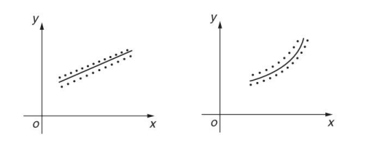

METHODS:
1.Linear Regression: One of the simplest forms of curve fitting, linear regression assumes a linear relationship between the independent and dependent variables. The goal is to find the best-fitting line (or hyperplane in higher dimensions) that minimizes the sum of squared differences between observed and predicted values.$(Y=AX+B or X=AY+B).$

2.Polynomial Regression: Polynomial regression extends linear regression by allowing the model to include higher-degree polynomials. This flexibility enables a better fit for nonlinear relationships in the data.$\left(Y=AX^{2}+BX+C\right)or\left( X=AY^{2}+BY+C\right).$
3.Exponential and Logarithmic: Exponential and logarithmic curve fitting is suitable for datasets exhibiting exponential growth or decay. These models are often used in fields like biology, physics, and finance.$(Y=e^{ax})$
Linear Regression:
Given the general form of a straight line  How can we pick the coefficients that best fits the line to the data?  First question: What makes a particular straight line a ‘good’ fit?  Why does the blue line appear to us to fit the trend better? | 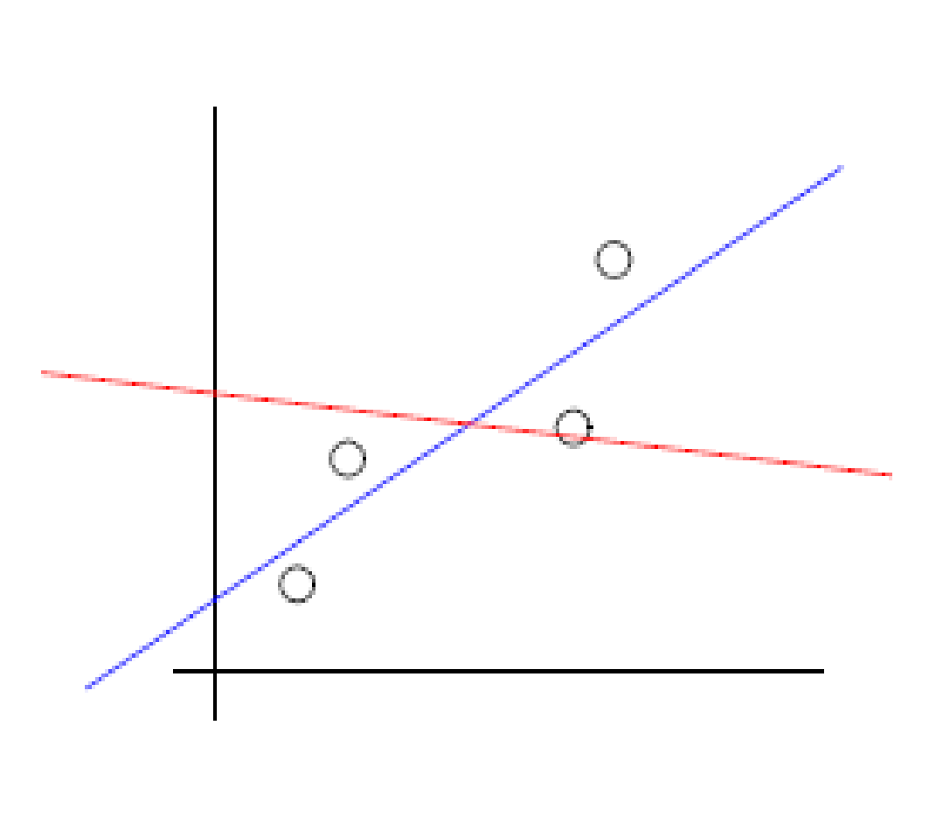
• Consider the distance between the data and points on the line  • Add up the length of all the red and blue verticle lines  • This is an expression of the ‘error’ between data and fitted line  • The one line that provides a minimum error is then the ‘best’ straight line  Quantifying errors in a curve fit | 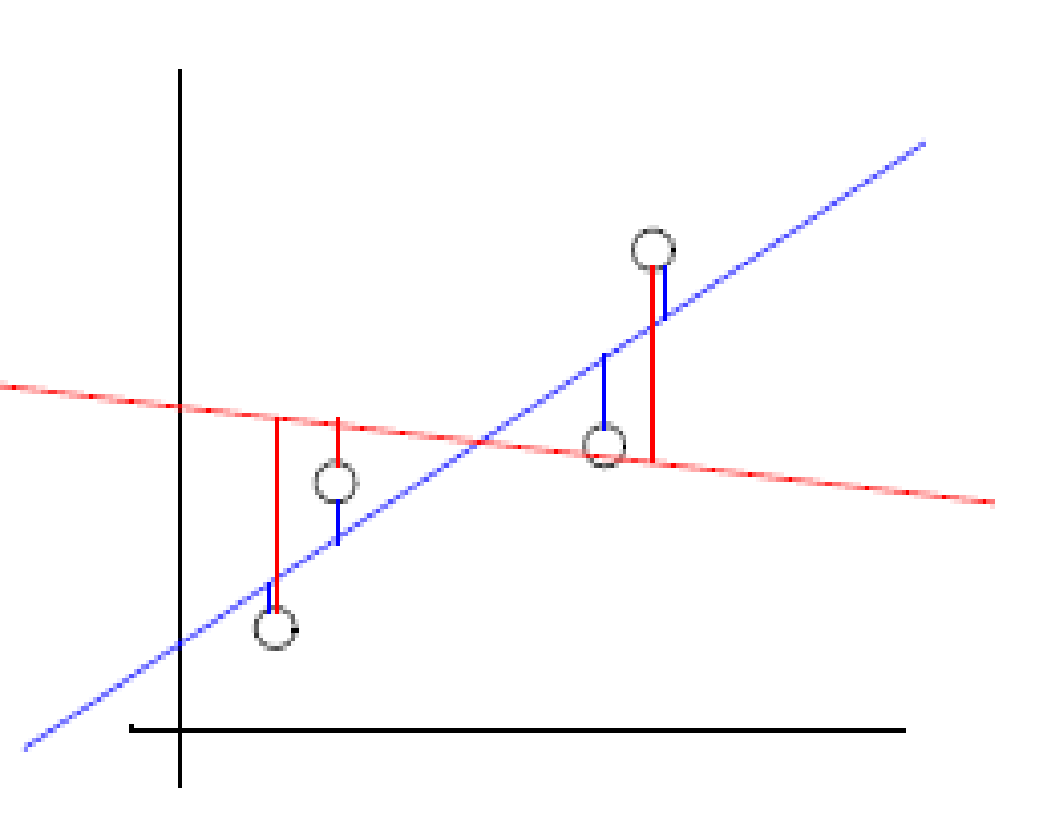
(1) positive or negative error have the same value (data point is above or below the line)  (2) Weight greater errors more heavily  we can do both of these things by squaring the distance denote data values as (x, y) ======>>  denote points on the fitted line as (x, f(x))  sum the error at the four data points | 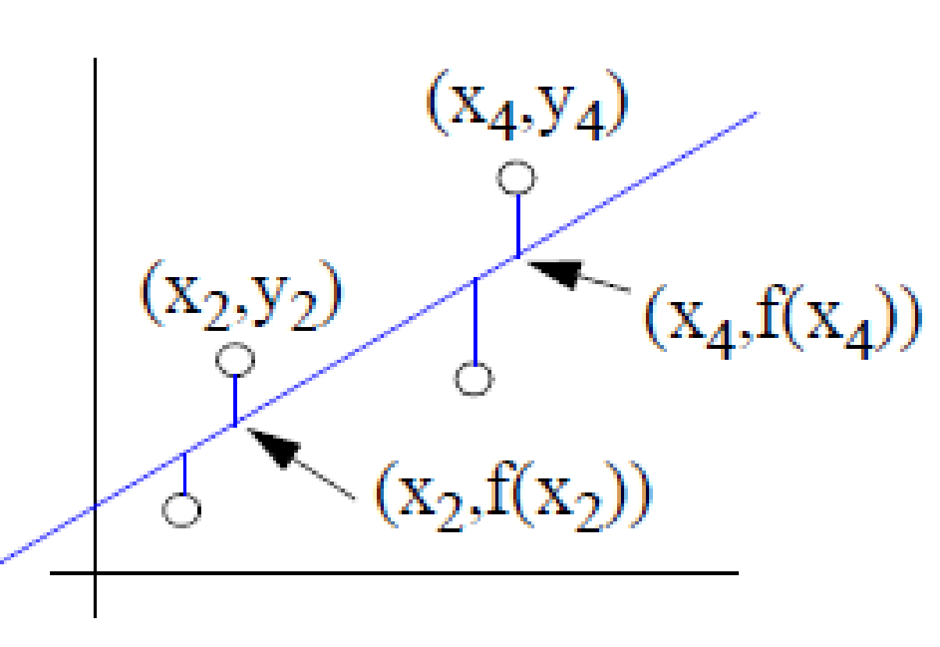
Error is minimum if first ordered partial derivatives=0
_{and}
Solve the equations
$$\sum_{i=1}^{n}{y_{i}=a}\sum_{i=1}^{n}{x_{i}+nb} \left(1\right)$$
$$\sum_{i=1}^{n}{x_{i}y_{i}}=a\sum_{i=1}^{n}{x_{i}^{2}+b\sum_{i=1}^{n}{x_{i}}} \left(2\right)$$

Example: 1 Fit a straight line to the following data:
$$x$$ | 1 | 2 | 3 | 4 | 6 | 8
$$y$$ | 2.4 | 3 | 3.6 | 4 | 5 | 6
Solution
Let the straight line to be fitted to the data be
$$y=a+bx$$
$$∑y=na+b∑x \left(1\right)$$
$$∑xy=a∑x+b∑x^{2} \left(2\right)$$
$$n=6$$

$$x$$ | $$y$$ | $$x^{2}$$ | $$xy$$
1 | 2.4 | 1 | 2.4
2 | 3 | 4 | 6
3 | 3.6 | 9 | 10.8
4 | 4 | 16 | 16
6 | 5 | 36 | 30
8 | 6 | 64 | 48
$$∑x=24$$ | $$∑y=24$$ | $$∑x^{2}=130$$ | $$∑xy=113.2$$
Substituting these values inn Eqs (1) and (2)
$$24=6a+24b \left(3\right)$$
$$113.2=24a+130b (4)$$
Solving Eqs (3) and (4), we get
$$a=1.9764$$
$$b=0.5059$$
Hence, the required equation of straight line is $y=1.9764+0.5059x$

Example: 2 Fit a straight line to the following data. Also, estimate the value of y at $x=2.5$.
$$x$$ | 0 | 1 | 2 | 3 | 4
$$y$$ | 1 | 1.8 | 3.3 | 4.5 | 6.3

Example: 3 Fit a straight line using least square method.
$$x$$ | 0 | 0.5 | 1 | 1.5 | 2 | 2.5
$$y$$ | 0 | 1.5 | 3 | 4.5 | 6 | 7.5

Example: 4 Fit a straight line to the following data and hence find $y$ when $x=70$
$$x$$ | 71 | 68 | 73 | 69 | 67 | 65 | 66 | 67
$$y$$ | 69 | 72 | 70 | 70 | 68 | 67 | 68 | 64

Polynomial Regression: We started the linear curve fit by choosing a generic form of the straight line $f\left(x\right)=ax+b$
This is just one kind of function. There are an infinite number of generic forms we could choose from for almost any shape we want. Let’s start with a simple extension to the linear regression concept recall the examples of sampled data.

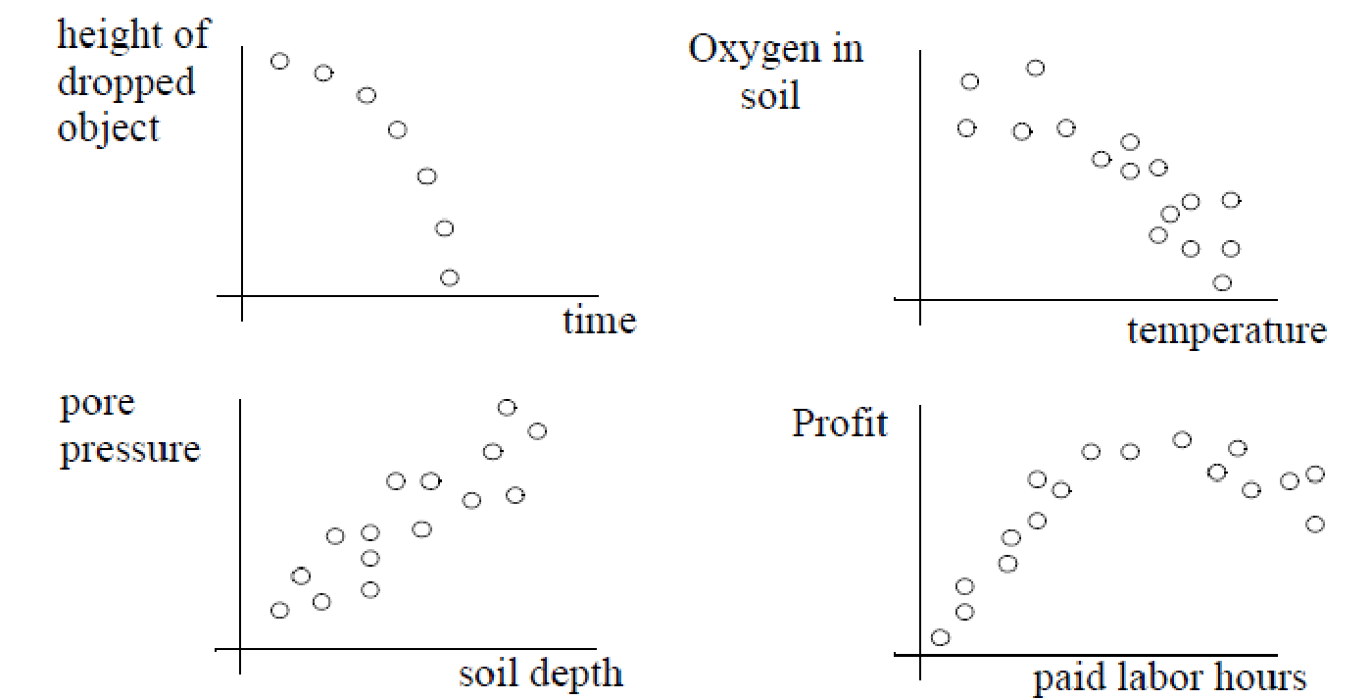

Error - Least squares approach

To minimize the error, derivatives with respect to $a,b and c$ equal to 0.

Simplify these equations, we get

Example: 1
Fit a least squares quadratic curve to the following data:
$$x$$ | $$1$$ | $$2$$ | $$3$$ | $$4$$
$$y$$ | $$1.7$$ | $$1.8$$ | $$2.3$$ | $$3.2$$
Estimate $y(2.4)$.
Solution:
Let the equation of the least squares quadratic curve (parabola) be $y=a+bx+cx^{2}$.
The normal equations are
$$\sum{y}=na+b\sum{x}+c\sum{x^{2}} (1)$$
$$\sum{xy}=a\sum{x}+b\sum{x^{2}} +c\sum{x^{3}} (2)$$
$$\sum{x^{2}y}=a\sum{x^{2}}+b\sum{x^{3}} +c\sum{x^{4}} (3)$$

Here, $n=4$
$$x$$ | $$y$$ | $$x^{2}$$ | $$x^{3}$$ | $$x^{4}$$ | $$xy$$ | $$x^{2}y$$
1 | 1.7 | 1 | 1 | 1 | 1.7 | 1.7
2 | 1.8 | 4 | 8 | 16 | 3.6 | 7.2
3 | 2.3 | 9 | 27 | 81 | 6.9 | 20.7
4 | 3.2 | 16 | 64 | 256 | 12.8 | 51.2
$\sum{x=}10$ | $\sum{y=}9$ | $\sum{x^{2}=30}$ | $\sum{x^{3}=}100$ | $\sum{x^{4}=354}$ | $\sum{xy=}25$ | $\sum{x^{2}y=80.8}$

Substitute these values in equations (1), (2) and (3),
$$9=4a+10b+30c$$
$$25=10a+30b+100c$$
$$80.8=30a+100b+354c$$

Solving the above equations, we get
$$a=2, b=-0.5, c=0.2$$
Hence, the required equation of quadratic curve is
$$y=2-0.5x+0.2x^{2}$$
$$y\left(2.4\right)=2-\left(0.5\right)\left(2.4\right)+\left(0.2\right){\left(2.4\right)}^{2}=1.952$$

Example: 2
Fit a second-degree polynomial using least square method to the following data:
$$x$$ | 0 | 1 | 2 | 3 | 4
$$y$$ | 1 | $$1.8$$ | $$1.3$$ | 2.5 | 6.3

Example: 3
Fit a second order polynomial $y=a+bx+cx^{2}$ to following data, using least square method.
$$x$$ | 0 | 5 | 10 | 15 | 20
$$y$$ | 7 | 11 | 16 | 20 | 26

Curve fitting - Other nonlinear fits (exponential)
Q: Will a polynomial of any order necessarily fit any set of data?
A: Nope, lots of phenomena don’t follow a polynomial form. They may be, for example, exponential
(1) General exponential equation
Now, take log on both side, we get
Which is equation of line, the original data in xy- plane mapped into XY-plane. This is called linearization. The data transformed as .

To find the value of we will use the equations
(1)
(2)
After getting values of , .

Example: An experiment gave the following values:
X | 1 | 5 | 7 | 9 | 12
Y | 10 | 15 | 12 | 15 | 21

Fit an exponential curve
Solution:

X _{I} = x_{i}
1 | 10 | 2.302585 | 1 | 2.302585
5 | 15 | 2.70805 | 25 | 13.54025
7 | 12 | 2.484906 | 49 | 17.39435
9 | 15 | 2.70805 | 81 | 24.37245
12 | 21 | 3.044522 | 144 | 36.53427
=34 |  | =13.24811 | =300 | =94.1439

A=2.00479, B=2.248664
a=antilog2.00479=7.424536, b=antilog (2.248664) =9.475068
Hence, best fit curve is
(2)
Taking log₁₀ on both the side
(1)
(2)

Example: An experiment gave the following values:
v (ft/min) | 350 | 400 | 500 | 600
t (min) | 61 | 26 | 7 | 2.6

It is known that v and t are connected by the relation , find the best possible values of a and b

V | t | Y=logv | X=logt | X² | XY
350 | 61 | 2.544068 | 1.78533 | 3.18740262 | 4.542001
400 | 26 | 2.60206 | 1.414973 | 2.002149575 | 3.681846
500 | 7 | 2.69897 | 0.845098 | 0.714190697 | 2.280894
600 | 2.6 | 2.778151 | 0.414973 | 0.17220288 | 1.152859
 |  | =10.62325 | =4.460375 | =6.075945772 | =11.6576
Substitute in given equation,
(1)
(2)

On solving these equations B=2.845 A=a= - 0.17.

3) The following values of T and l follow the law T= al^{n}. Test if this is so and find the best values of a and n.
T | 1.0 | 1.5 | 2.0 | 2.5
L | 25 | 56.2 | 100 | 1.56

Reference Books
  - Fundamentals of Mathematical Statistics By S.C. Gupta and V. K. Kapoor
  - Introductory Statistics Prem. S .Mann








